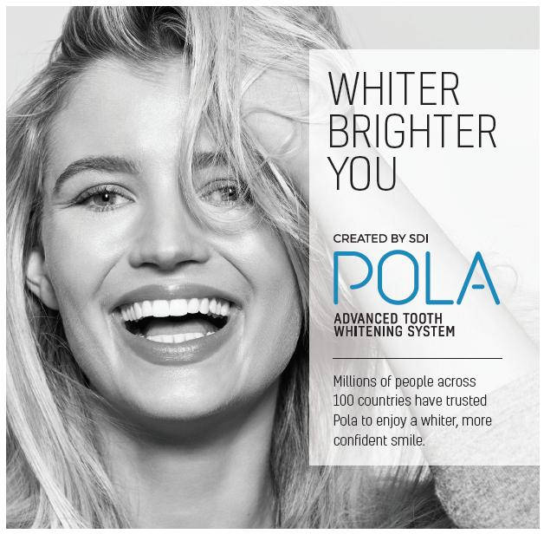

# How to get a whiter more confident smile.

We are passionate about helping patients achieve whiter, brighter smiles. At [YOUR COMPANY], our office provides Pola Advanced Tooth Whitening. Pola is trusted by millions of people across 100 countries to achieve a whiter, brighter more confident smile.

[Click to download [Pola](https://us.polawhite.com.au/wp-content/uploads/sites/18/2022/01/Pola-web-hero.jpg) Hero image]

# In chair whitening

Walk out with a whiter more confident smile in 24 minutes. Pola Rapid is designed to give you whiter results in record time. Pola’s unique formulation dissolves and releases the active whitening ingredient immediately to initiate the whitening process. By breaking down and releasing the peroxide ions fast, Pola’s whitening process is triggered.

Pola Rapid contains the fastest bleach available to safely whiten teeth in 24 minutes at a neutral pH to protect your tooth and gums.

Pola Rapid also contains Pola Desensitising Technology (PDT). The combination of neutral pH and PDT reduces the likelihood of gum irritation, burning, pain or long term gum damage.

Pola Rapid requires only one 24 minute visit in chair to achieve whiter teeth and a more confident smile. The ease and convenience of Pola Rapid PDT enables you to achieve whiter teeth while protecting your teeth and gums.

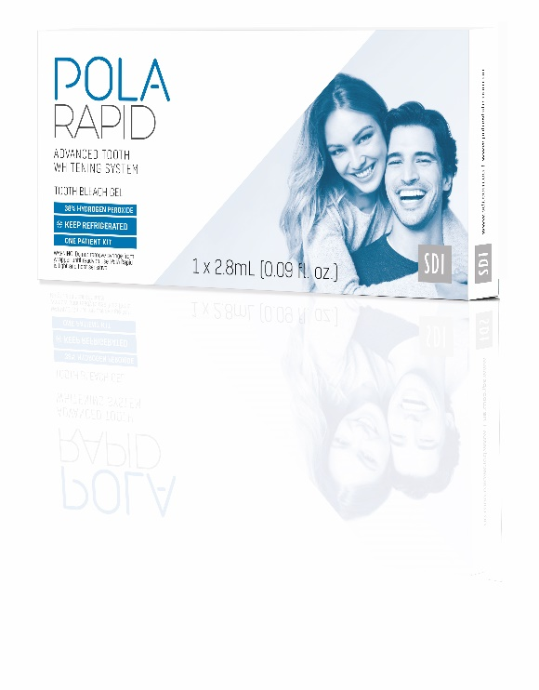

[Click to download [Pola Rapid image](https://www.sdi.com.au/downloads/Image_library/pola/pola-rapid-1patient-lo.jpg)]

# At home whitening kits

Whiten your teeth in the comfort of your own home, at a time that suits you.

# Pola Day and Pola Night

Both Pola Day and Pola Night has a neutral pH teeth whitening formulation that can achieve your desired whitening effect in as little as 30 – 45 minutes a day. Each contains fluoride to remineralise your teeth and protect them against tooth sensitivity. After a full check up, we will supply your own whitening kit with custom made trays and Pola whitening gels for whiter teeth in 5-14 days.

Pola Day uses hydrogen peroxide, a fast acting tooth whitening ingredient to get you a whiter smile sooner. While the unique Pola formula has built in desensitising technology which will minimise sensitivity, a small minority of patients may experience sensitivity, which can be managed with shorter, more frequent whitening treatments, or by changing to Pola Night.

Pola Night uses carbamide peroxide, a more gentle tooth whitening ingredient which is better suited to sensitive teeth. Using Pola Night’s more gentle formula will require a longer treatment time.

We can help guide you to the best strength for your teeth. In general, the higher the concentration, the quicker the treatment – however stronger concentrations can lead to sensitivity.  If the directions are followed, each concentration will ultimately give the same result – a whiter, more confident smile.

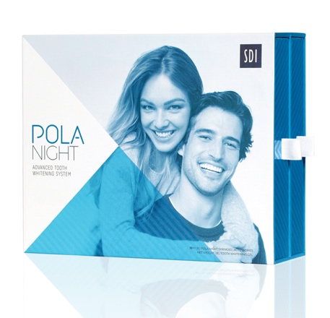

[Click to download [Pola Night image](https://www.sdi.com.au/downloads/Image_library/pola/Pola-night-10-syringe-closed_lo.jpg)]

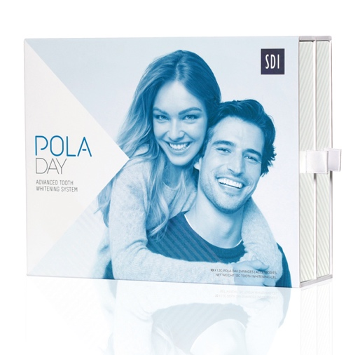

[Click to download [Pola Day image](https://www.sdi.com.au/downloads/Image_library/pola/pola-day-10-syringe-closed_lo.jpg)]

# Pola Light

The Pola Light advanced tooth whitening system combines Pola’s award winning whitening formula, with targeted LED technology. And all from the comfort of your home.

Pola Light is fast acting, delivering you whiter teeth in 5 days and is formulated to safely remove long term stains

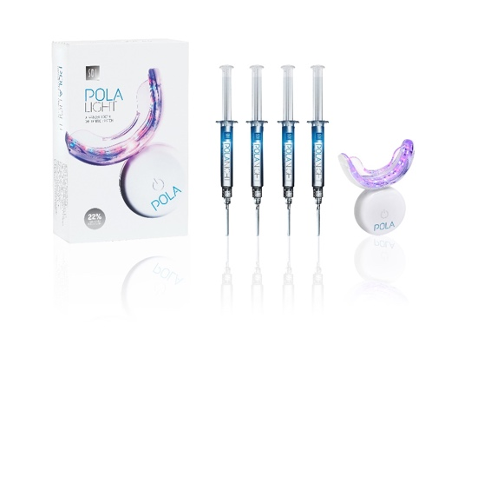[Click to download [Pola Light 22% image](https://www.sdi.com.au/downloads/Image_library/pola/pola_light_kit_22_LR.jpg)]

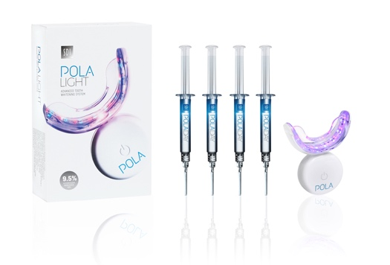[Click to download [Pola Light 9.5% image](https://www.sdi.com.au/downloads/Image_library/pola/pola_light_kit_9.5_LR.jpg)]

# Pola Luminate

Use Pola Luminate to top up your whitening shade between longer term treatments. Simply brush on Pola Luminate directly to your teeth to enjoy whiter teeth on the go.

Designed to fit easily into your jacket, pocket or handbag, this fast acting whitening gel delivers a quick whitening touch up when you need it.

[Click to download [Pola Luminate image](https://www.sdi.com.au/downloads/Image_library/pola/pola_luminate_2020_lo.jpg)]

# Why should you choose Pola whitening over others and is it safe?

Some teeth whitening products are produced by companies with limited dental experience and unclear manufacturing origins. Most online tooth whitening systems only use sodium bicarbonate as the active whitening ingredient. This weaker formula can only treat mild surface stains.

Pola is produced by SDI, an Australian company that has 50 years experience in oral health. Pola’s scientific formula has been refined over many decades to ensure the best whitening result. Clinical studies have shown that teeth whitening with carbamide or hydrogen peroxide is safe if performed under the guidance and supervision of a trained dentist.

Better yet, Pola whitening gels can only be purchased through trusted dentists.