Dear xxxx
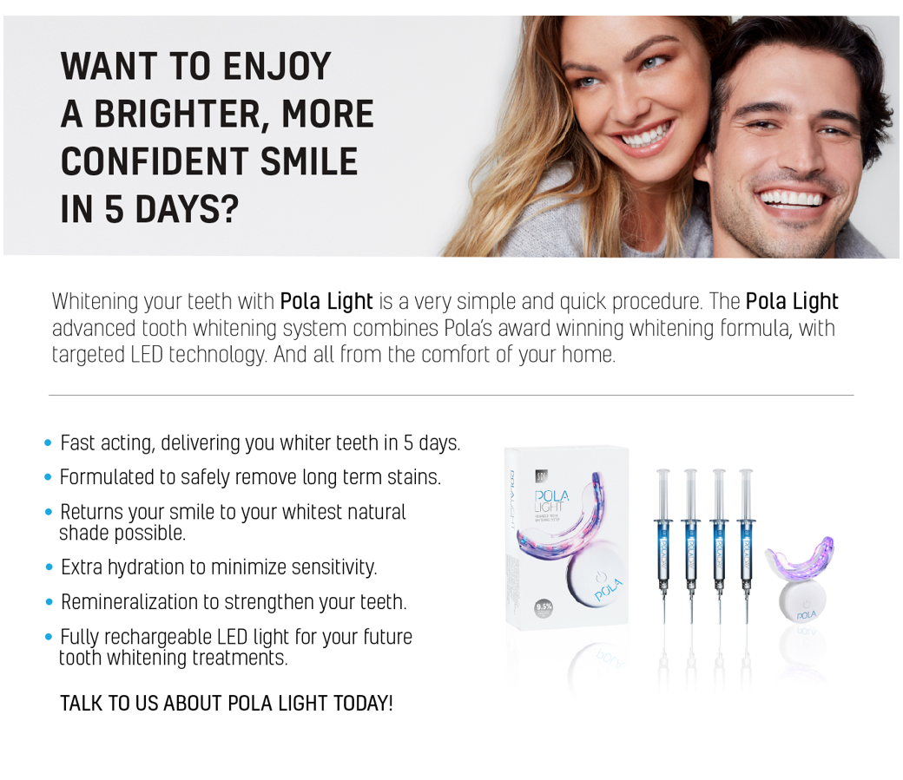
[Click here to download the Pola Light Email image]

Alternative text to sit behind image:

WANT TO ENJOY A BRIGHTER, MORE CONFIDENT SMILE IN 5 DAYS?
Whitening your teeth with Pola Light is a very simple and quick procedure. The Pola Light advanced tooth whitening system combines Pola’s award winning whitening formula, with targeted LED technology. And all from the comfort of your home.
• Fast acting, delivering you whiter teeth in 5 days.
• Formulated to safely remove long term stains.
• Returns your smile to your whitest natural shade possible.
• Extra hydration to minimize sensitivity.
• Remineralization to strengthen your teeth.
• Fully rechargeable LED light for your future tooth whitening treatments.
TALK TO US ABOUT POLA LIGHT TODAY!

