Dear xxxx
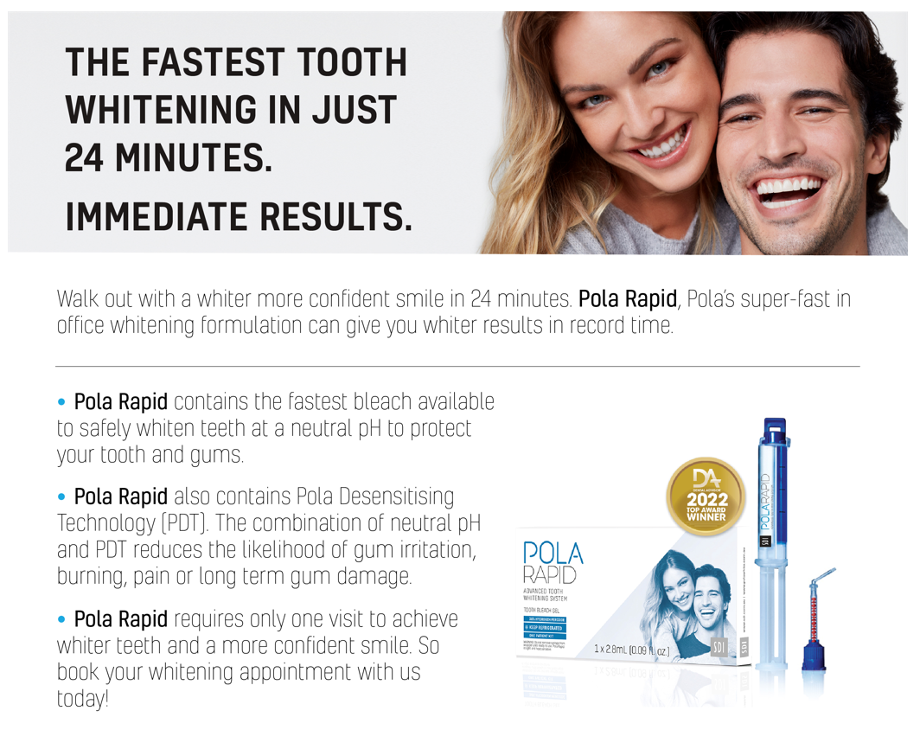

[Click here to download the Pola Rapid email image]

Alternative text to sit behind image:

THE FASTEST TOOTH WHITENING IN JUST 24 MINUTES.
IMMEDIATE RESULTS.

Walk out with a whiter more conﬁdent smile in 24 minutes. Pola Rapid, Pola’s super-fast in ofﬁce whitening formulation can give you whiter results in record time.

• Pola Rapid contains the fastest bleach available to safely whiten teeth at a neutral pH to protect your tooth and gums.
• Pola Rapid also contains Pola Desensitising Technology (PDT). The combination of neutral pH and PDT reduces the likelihood of gum irritation, burning, pain or long term gum damage.
• Pola Rapid requires only one visit to achieve whiter teeth and a more conﬁdent smile. So book your whitening appointment with us today!

