Dear xxxx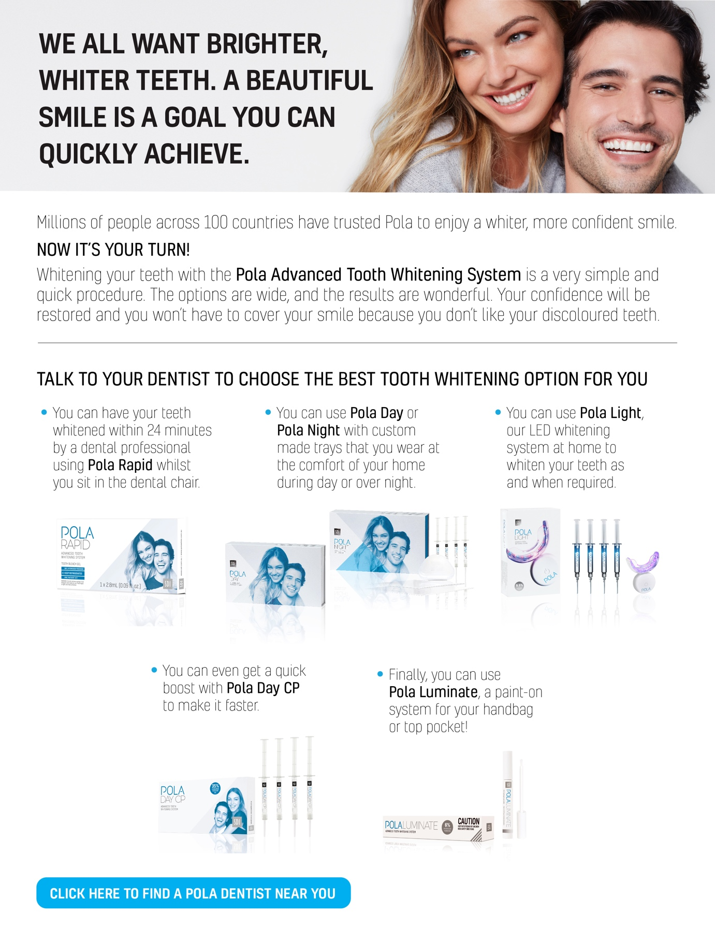
[Click here to download the Pola Range Email image]

Alternative text to sit behind image:

WE ALL WANT BRIGHTER, WHITER TEETH. A BEAUTIFUL SMILE IS A GOAL YOU CAN QUICKLY ACHIEVE.

Millions of people across 100 countries have trusted Pola to enjoy a whiter, more conﬁdent smile. NOW IT’S YOUR TURN!
Whitening your teeth with the Pola Advanced Tooth Whitening System is a very simple and quick procedure. The options are wide, and the results are wonderful. Your conﬁdence will be restored and you won’t have to cover your smile because you don’t like your discoloured teeth.

TALK TO US TO CHOOSE THE BEST TOOTH WHITENING OPTION FOR YOU
You can have your teeth whitened within 24 minutes by our dental professionals using Pola Rapid whilst you sit in the dental chair.
You can use Pola Day or Pola Night with custom made trays that you wear at the comfort of your home during day or over night.
You can use Pola Light, our LED whitening system at home to whiten your teeth as and when required.
You can even get a quick boost with Pola Day CP to make it faster.
Finally, you can use Pola Luminate, a paint-on system for your handbag or top pocket!

