Dear xxxx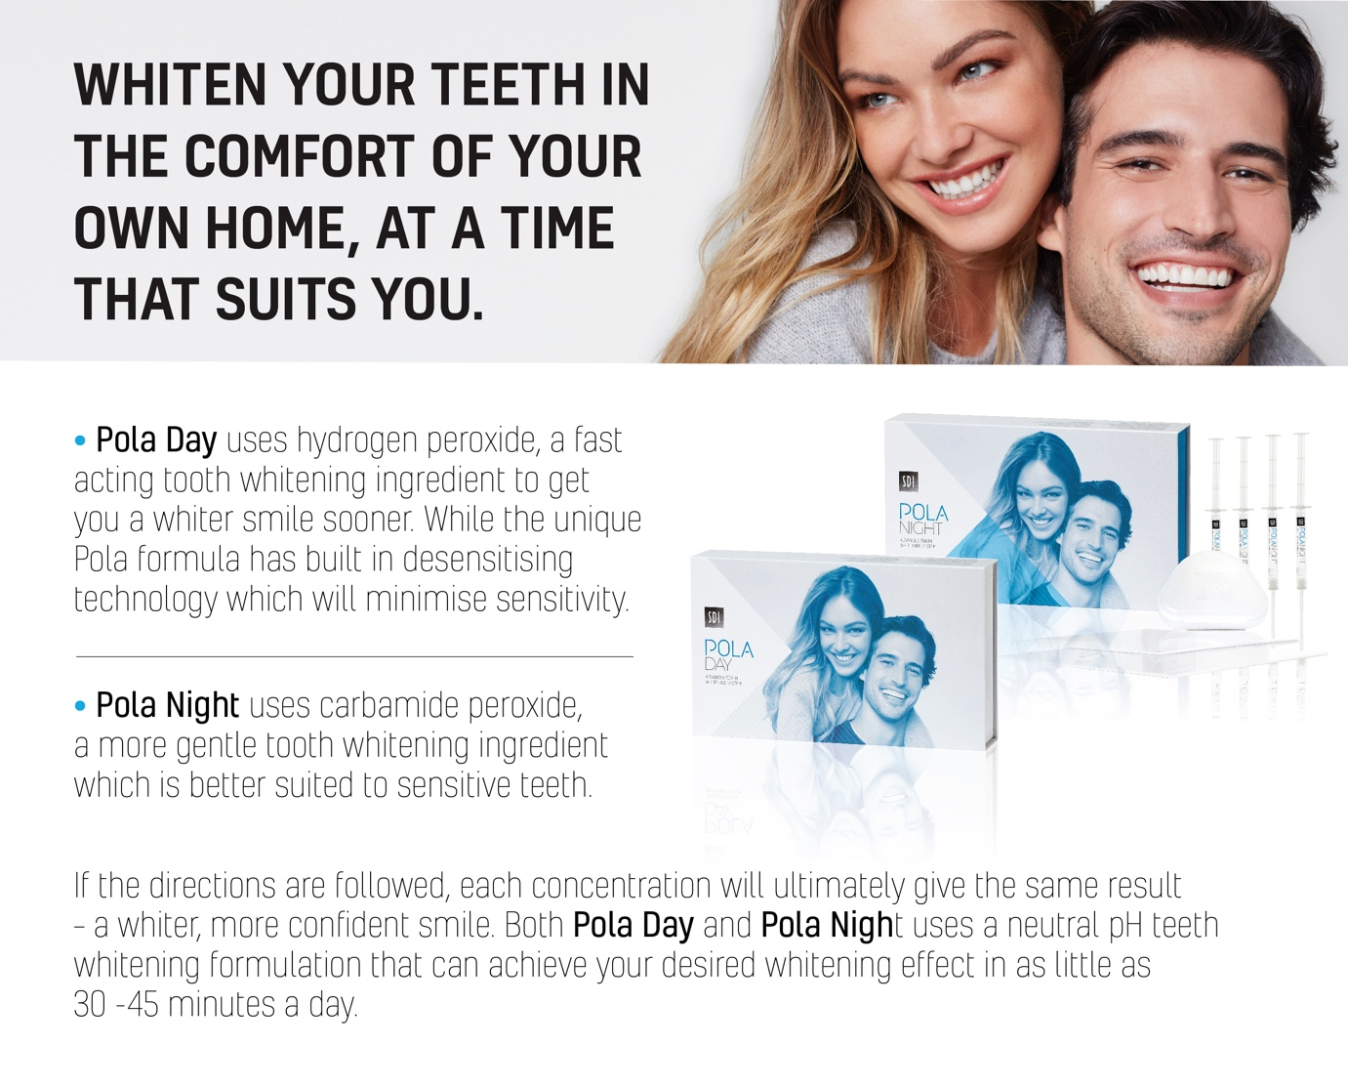

[Click here to download the Pola Day/Pola Night Email image]

Alternative text to sit behind image:

WHITEN YOUR TEETH IN THE COMFORT OF YOUR OWN HOME, AT A TIME THAT SUITS YOU.
Pola Day uses hydrogen peroxide, a fast acting tooth whitening ingredient to get you a whiter smile sooner. While the unique Pola formula has built in desensitising technology which will minimise sensitivity.
Pola Night uses carbamide peroxide, a more gentle tooth whitening ingredient which is better suited to sensitive teeth.
If the directions are followed, each concentration will ultimately give the same result – a whiter, more conﬁdent smile. Both Pola Day and Pola Night uses a neutral pH teeth whitening formulation that can achieve your desired whitening effect in as little as 30-45 minutes a day.

